Boundary Prospect, Mamainse Point Area,
Sault Ste. Marie, Ontario

Location, Access and History

The Baseline Property is located in Kincaid Township in the Sault Ste. Marie Mining Division. The property consists of one un-patented claim block (SSM 1192277) composed of 6 claim units totalling approximately 96 hectares in area. The property is accessible via Highway 17 North, about 100 kilometres north from Sault Ste. Marie, Ontario, and then by a short (1/2 km) gravel access road from Highway 17.

The Baseline Prospect was discovered in 1962 by C.C. Huston and Associates who undertook a comprehensive exploration program which included the northern half of the claim block. Coppercorp Limited explored the southern portion of the property. The exploration programs culminated in a diamond drill program consisting of 12 holes. In 1990, Palumbo and MacDougall completed general geological mapping, stripping, trenching and sampling on the Boundary Prospect.
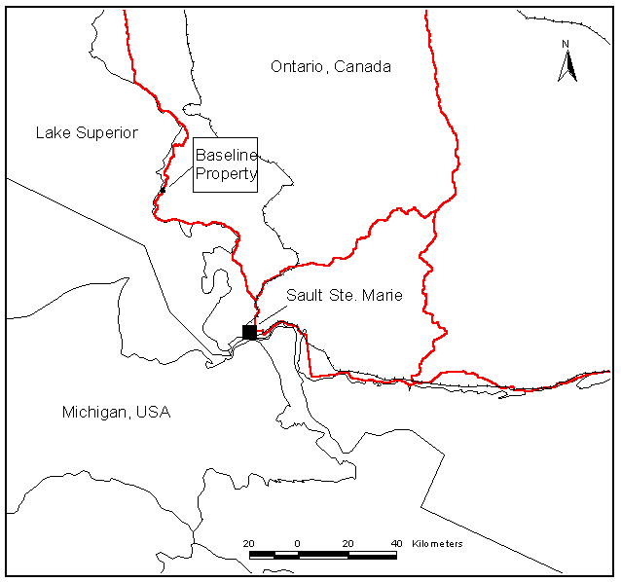
General Location Map of Baseline Property

Geology

The Baseline Prospect occurs in mid-Proterozoic, Keweenawan-age (1100-1200 Ma) lavas of the Mamainse Point Formation. The Mamainse Point Formation forms part of the eastern limit of the Mid-Continental Rift (MCR) system which underlies Lake Superior. The Mamainse Point Formation consists of a 6-km thick sequence of continental flood basalts intercalated with red-beds consisting of coarse conglomerates (fanglomerates) with minor sandstone interbeds. The volcanic lavas and sedimentary beds have been intruded by felsite, flow-banded rhyolite, and quartz-(+/-feldspar) porphyry, which occur predominantly as sub-volcanic sills.

General Geology, Mamainse Point Area
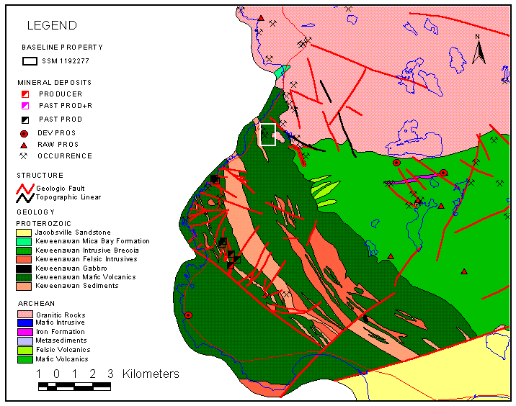
The western portion of Baseline Property is situated stratigraphically below the ‘Basalt Clast Conglomerate’ within a series of highly altered heterogenous basaltic flows. These basalt flows are characterized by the development of epidote-albite-chlorite-quartz-calcite mineral assemblages which have pervasively replaced the amygdaloidal flow tops and bases of the thicker flows and completely replace the mineralogy of the thinner flows.
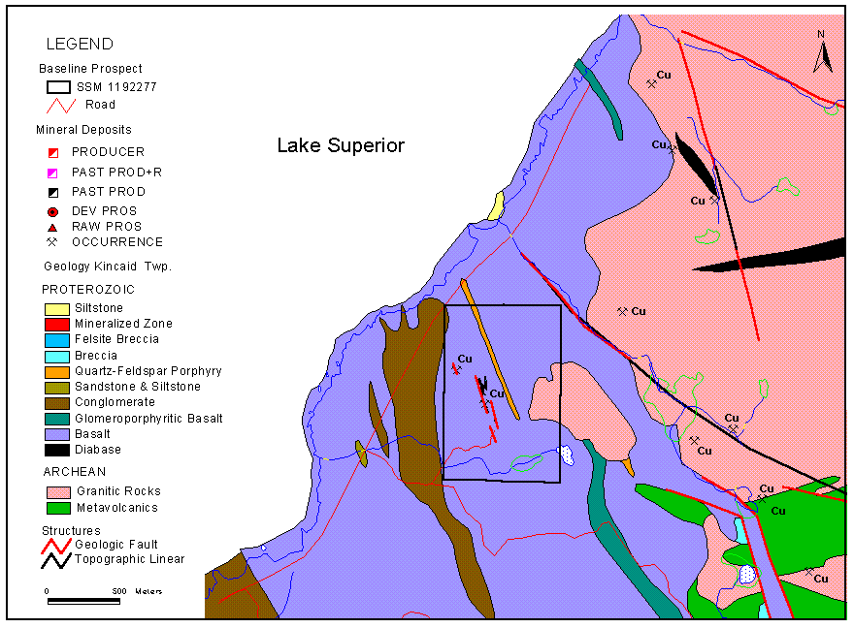
Local Geology, Boundary Property, Mica Bay Area

A quartz-feldspar prophyry sill intrudes the altered basalts and is characterized by large euhedral potash feldspar and round quartz ‘eyes’ in a fine-grained siliceous matrix containing minor disseminated sulphides. The QFP sill occurs along strike to the southeast and was intersected by several of the Coppercorp drill holes. Notably, the QFP sill contains minor disseminated chalcocite, chalcopyrite and pyrite in the drill core. Felsite dykes and sills intrude the basalt lavas and some appear to be closely associated with the mineralized zones of the Boundary Prospect where they occur as felsite breccias and are intensely hematized and silicified.

The Baseline Prospect lies close to the Keweenawan/Archean unconformity where thin strips of fault bounded Keweenawan lava occur within the metavolcanic rocks of the Batchewana Greenstone Belt. These fault blocks of lava (graben) are associated with large areas of fault or vein breccia. Copper occurrences considered to be Keweenawan in age occur within the granites and appear to be spatially associated with the north-northwest trending structures.

Previous Exploration

Previous exploration outlined of two sub-parallel, Cu-Ag-Au-bearing mineralized zones which strike N20W and dip to the east at between 45º and 70º . The two mineralized zones occur within basalt lavas which strike north-northwest and dip 35-45 º west. The western-most zone, referred to as the ‘Boundary Vein’ can be traced over a length of about 260 metres. The eastern mineralized zone, referred to as the ‘K-8 vein’, occurs about 40 metres east of the Boundary Vein and extends over a distance of about 180 metres and over an average width of about one metre. Both zones appear to have an ‘en echelon’ structural disposition and together have a combined length of about 400 metres.

Location of Prior Exploration Work
Mineralization consists of chalcopyrite, bornite, pyrite and chalcocite and minor native copper erratically distributed in quartz-carbonate breccias and veins. Malachite stain is pervasive on the fracture surfaces throughout the stripped mineralized areas. Mineralized quartz-carbonate breccia was more commonly noted for the Boundary Vein, whereas quartz-carbonate veins predominate in the K-8 structure.

A quartz-feldspar porphyry sill was intersected in the footwall rocks beneath the K-8 Vein and adjacent to a north-trending fault zone which appears to separate the Boundary and K-8 Veins. The porphyry contained finely disseminated chalcocite and chalcopyrite over a 6 metre interval but carried low grades of copper (0.31% Cu over 1.2 metres, McMurchy, 1962).

Summary of higher-grade diamond drill hole intersections
DDH | Cu (%) | Ag (oz/t) | Width (ft) | Vein System
K-4 (Huston) | 2.95 |  | 1.10 | Boundary Vein
K-5 (Huston) | 1.10 | 0.42 | 2.3 | K-8 Vein
K-5 (Huston | 1.25 | 0.44 | 4.5 | K-8 Vein
K-6 (Huston) | 2.78 | 1.13 | 4.7 | Boundary Vein
CC62-2 (Coppercorp) | 3.19 | 0.68 | 6.0 | K-8 Vein
CC62-3 (Coppercorp) | 2.14 | 1.58 | 4.6 | K-8 Vein
CC62-4 (Coppercorp) | 4.35 | 1.02 | 3.5 | K-8 Vein
CC62-5 (Coppercorp) | 2.30 | 0.52 | 4.4 | K-8 Vein
Note: Both Huston & Associates and Coppercorp Limited did not assay for gold in drill core.

Summary of Cu, Ag, Au assays of trench chip sampling by Dan Macdougall
 |  |  | South Boundary & K-8 Vein
Trench ID | Width (ft) | Cu (%) | Ag (ppm) | Ag (oz/t) | Au (oz/ton) | Au (g/t) | Au (ppb) | Notes
22 | 8.00 | 0.97 | 3.60 | 0.11 | 0.003 | 0.103 | 103 | Wawa Assaying
23 | 5.00 | 7.78 | 26.40 | 0.77 | 0.009 | 0.309 | 309 | Wawa Assaying
24 | 4.00 | 5.34 | 37.60 | 1.10 | 0.005 | 0.171 | 171 | Wawa Assaying
25 | 3.00 | 2.52 | 19.10 | 0.56 | 0.003 | 0.103 | 103 | Wawa Assaying
26 | 4.00 | 4.05 | 12.70 | 0.37 | tr | tr | tr | Wawa Assaying
27 | 5.00 | 1.31 | 3.50 | 0.10 | tr | tr | tr | Wawa Assaying
28 | 4.00 | 7.07 | 8.30 | 0.24 | 0.016 | 0.549 | 549 | Wawa Assaying

Summary and Interpretation

The Baseline Prospect occurs in north-northwest trending fault-breccia zones, within the altered basalt lava flows. The local structural setting supports the view of a structurally active extensional environment characterized by the development of fault blocks which could provide channel-ways for mineralizing fluids. The controlling structures are similar in orientation and character to those at the Coppercorp deposit, but the Baseline Prospect appears to be within a more intense of zone of alteration. The mineralogy is essentially the same as that of the Coppercorp deposit consisting of chalcocite, chacopyrite, bornite and pyrite contained in quartz-carbonate breccias and veins.

Most of the major ore controlling structures in the Mamainse area copper mines strike NNW and dip steeply to the east (Coppercorp C-Zone, SB-Zone, Mamainse Vein) and are offset by NNE-trending faults with a steep southeast dip. A simple structural model that fits these deposits is one where listric normal faults are produced near the edge of the rifted basin as a response to the increasing thickness, weight and sagging of the flood basalts and underlying crust. Repeated movement on these major faults results in the development of antithetic or conjugate faults with related fracturing and brecciation. These structural zones could tap magmatic sources and hydrothermal ore-bearing fluids from deeper levels.

Like the Coppercorp and Tribag deposits, the Baseline Prospect displays many of the characteristics of the IOCG deposit type. Mineralization is hosted in rocks which are mid-Proterozoic in age, occurring in an extensional environment closely associated with volcano-sedimentary rocks in a high oxidation state. The similarity with other copper deposits like Coppercorp, the presence of felsite and quartz-feldspar porphyry intrusives in the immediate area suggests a similar model, with the deposit forming as a result of interaction between hot magmatic fluids and a lower temperature, possibly hydrothermal-metamorphic fluid.

Structural Model

The area occupied by the vein systems and between the vein systems is characterized by variable degrees of brecciation, fracturing, alteration and mineralization. Once out of the structurally disturbed area the rocks are typically massive, amygdaloidal basalts with limited fracturing and alteration. Rather than two ‘vein systems’ the Baseline Prospect is better described as a 50 metre-wide zone of structural dislocation with the Boundary Vein and K-8 Vein representing zones of more intense fracturing and brecciation.

Idealized Cross-Section across the Baseline Prospect
The structural orientation of the Baseline Prospect and the presence of granitic basement rocks in the footwall may reflect the development of horst and graben-like structures which appear to have developed further to the east near the assumed edge of the rift. The Baseline structural zone may represent an ‘antithetic’ or conjugate fault related to a larger scale listric normal fault.

Future Exploration

Phase 1:
- Detailed geological mapping needs to be completed over the property and over the stripped areas. The objectives of the mapping should include: a) delineation of the QFP, felsite and felsite breccia along strike, b) determine the contact relationship between the volcanics and granite basement, c) identify the possible continuation of the 'Daisy Stone' basalt flow.
- Survey control of the drill hole collars, stripped areas and trenches. This would involve establishing a baseline with cross lines at 25 metre intervals. Second-order control points should be established and brought in from the nearest benchmark on Highway 17.
- Ground magnetic and VLF-EM orientation surveys to determined the response and strength of the mineralized/structural zone. This can be completed on several cross-lines at 25-metre spacing.
- Grab and chip sampling of mineralized trenches to confirm Cu, Ag, and Au content.
- Prospecting and reconnaissance soil sampling in the area of the NW Vein and south of the Boundary Prospect.

Phase 2:
- Induced Polarization survey to assess the depth and strike extent of the mineralized-structural zone. Coppercorp drill holes may allow access for down-hole IP.
- Ground magnetic survey of the property at 25-50 metre line spacing in the area of the Boundary Prospect and at 100 metres for the remainder.
- Diamond drill hole program to test identified target areas such as:
- Deep drill hole to intersect mineralized structures below 200 metres,
- Vertical drill hole south and west of CC62-10 to test the mineralized porphyry and intersect the volcanic/granite unconformity.

For further information and a preliminary geological report on the property please contact:

Delio Tortosa, P.Eng., M.Sc.
RR#1, 110 Robertson Lake Road
Goulais River, Ontario, P0S 1E0
Telephone: (705) 649-0763
Email: eliris@soonet.ca

